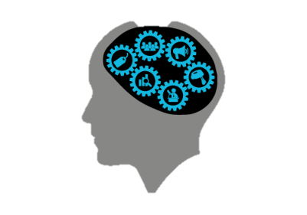
Course Title: Culturally Responsive Teaching & the Brain: Preparing Independent Learners
Department and Course Code:
Registration link:
Required Resource:
Hammond, Z. (2015). Culturally responsive teaching and the brain: Promoting authentic engagement and rigor among culturally and linguistically diverse students. Thousand Oaks, CA: Corwin.

Additional Course Materials:
- Study guides
- Journal (either paper or online)
- Menu for Success Options Handout
Description:
This course will assist educators in understanding the connections between neuroscience, learning, and culture. It also will describe easy-to-implement strategies to help push dependent learners become independent learners. Additionally, the educator will examine and reflect on his/her implicit and explicit beliefs, values, and philosophies. Completing this course will help educators use brain-based research to create or enhance a culturally responsive learning environment for all learners.

Objectives:
Upon completion of this course, participants will:
- Understand the basic neuroscience of learning and culture;
- Explain connections between learning and culture;
- Describe how to build learning partnerships with learners;
- Examine and question current cultural philosophies, strategies, and practices;
- Develop resources to implement into the culturally responsive learning environment.

Course Activities and Requirements:
All course activities are located and submitted on Moodle. If you have not already received a link to the Moodle course, please contact the course instructor.
- Reflection questions written or typed—just select a couple from the end of each chapter (do not need to be submitted but are used in lieu of the discourse that would occur in a face-to-face book study)
- Study guides
- Written assignments—Select two Menu for Success Options to submit by the end of the course
- The book study course evaluation

Evaluation Plan: Satisfactory/Unsatisfactory
A check mark indicates meeting the outcome. No check will be given if participant does not make a good-faith attempt to meet the outcome.
❏ Completed one Menu for Success written assignment
❏ Completed a second Menu for Success written assignment
❏ Completed book study guides
❏ Completed course evaluation

Independent Study Course outline:
Topic | Agenda | Time
Part 1a  Building Awareness and Knowledge | Read:  - Introduction (pp. 1–9)  - Chapter 1 (pp. 12–20)  - Chapter 2 (pp. 21–35)  Complete:  - Chapters 1 & 2 reflection questions  - Submit chapters 1 & 2 study guide  - Analyze the Menu for Success Options written assignment choices (you will select two options) | 3 hours
Part 1b  Building Awareness and Knowledge Cont. | Read:  - Chapter 3 (pp. 36–51)  - Chapter 4 (pp. 52–70)  Complete:  - Chapters 3 & 4 reflection questions  - Submit chapters 3 & 4 study guide  - Begin selecting/developing two written assignments | 3 hours
Part 2  Building Learning Partnerships | 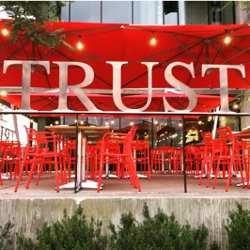  Read:  - Chapter 5 (pp. 72–87)  - Chapter 6 (pp. 88–107)  - Chapter 7 (pp. 108–120)  Complete:  - Chapters 5–7 reflection questions  - Submit chapters 5–7 study guide  - Continue with developing two written assignments | 3 hours
Part 3  Building Intellective Capacity | Read:  - Chapter 8 (pp. 122–141)  - Chapter 9 (pp. 142–151)  - Epilogue (pp. 152–154)  Complete:  - Chapters 8 & 9 reflection questions  - Submit chapters 8 & 9 study guide  - Final touches on two written assignment | 3 hours
Prior to Semester Deadline | Complete and submit:  - Two written assignments from the Menu for Success Options  - Course evaluation | 3 hours

